DESIGN
Stage 3

Student Number:

Time allowed for this paper
Reading time before commencing work: ten minutes
Working time for paper: two and a half hours

Materials required/recommended for this paper
To be provided by the supervisor
This Question/Answer Booklet

To be provided by the candidate
Standard items: pens (blue/black preferred), pencils (including coloured), sharpener, correction liquid/tape, eraser, ruler, highlighters

Special items: non-programmable calculators approved for use in the WACE examinations, approved drawing instruments consisting of a drawing compass, set square, dividers, protractor, templates,

Tick ( ) one of the boxes below to indicate the context that you studied this year.

Context

Photography

Graphic

Technical graphics

Dimensional

Number of additional answer booklets used (if applicable):

Important note to candidates
No other items may be taken into the examination room. It is your responsibility to ensure
that you do not have any unauthorised notes or other items of a non-personal nature in the examination room. If you have any unauthorised material with you, hand it to the supervisor before reading any further.

Structure of the examination

The WACE Design Stage 3 examination consists of a written component worth 50 per cent of the total examination score and a practical (portfolio) component worth 50 per cent of the total examination score.

Structure of this paper
Section | Number of questions available | Number of questions to be answered | Suggested working time (minutes) | Marks available | Percentage of total exam
Section One: Short response | 5 | 5 | 30 | 27 | 15
Section Two: Extended response | 2 | 2 | 120 | 38 | 35
 | 4 | 1
 |  |  |  |  | 50

Total

Instructions to candidates

1. The rules for the conduct of Western Australian external examinations are detailed in the Year 12 Information Handbook 2013. Sitting this examination implies that you agree to abide by these rules.

2. Write your answers in this Question/Answer Booklet.

3. Section One contains five (5) questions. Answer all questions.

4. Section Two contains six (6) questions. You must answer Questions 6 and 7. Answer
one (1) question from Questions 8 to 11.

5. You must be careful to confine your responses to the specific questions asked and to follow any instructions that are specific to a particular question.

6. Spare pages are included at the end of this booklet. They can be used for planning your responses and/or as additional space if required to continue an answer.
Ɣ Planning: If you use the spare pages for planning, indicate this clearly at the top of the page.
Ɣ Continuing an answer: If you need to use the space to continue an answer, indicate in the original answer space where the answer is continued, i.e. give the page number. Fill in the number of the question that you are continuing to answer at the top of the page.

STAGE 3 | 3 | DESIGN
6HFWLRQ 2QH: 6KRUW UHVSRQVH |  | 15% (27 0DUNV)

This section has ¿YH (5) questions. Answer all questions. Write your answers in the space provided.

Spare pages are included at the end of this booklet. They can be used for planning your responses and/or as additional space if required to continue an answer.
Ɣ Planning: If you use the spare pages for planning, indicate this clearly at the top of the page.
Ɣ Continuing an answer: If you need to use the space to continue an answer, indicate in the original answer space where the answer is continued, i.e. give the page number. Fill in the number of the question that you are continuing to answer at the top of the page.

Suggested working time: 30 minutes.

Question 1 (6 marks)

Discuss the integration of three elements and three principles of design used in Figure 1.

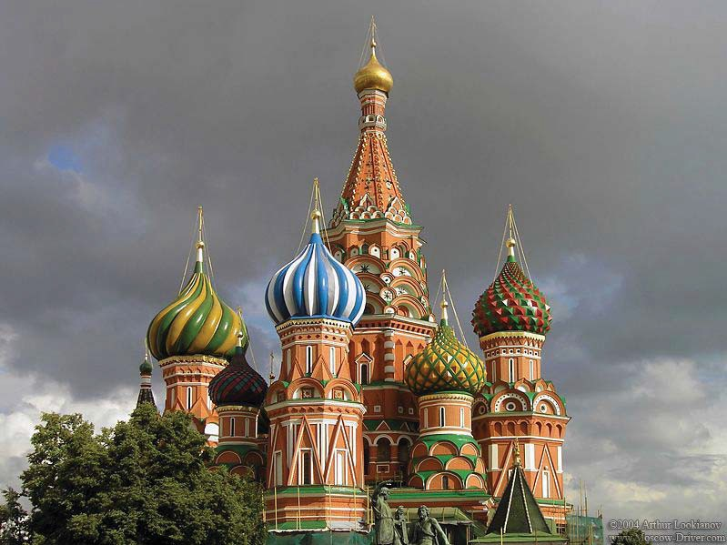

Figure 1

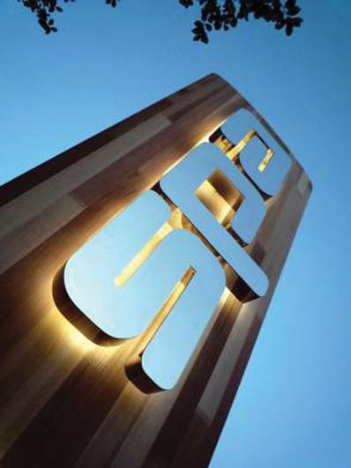

Sustainable sign system using wood offcuts, Signbox,
http://www.signsny.com/images/carved-signs/carved-art-of-shaving.JPG
2011
http://www.signsny.com/images/carved-signs/carved-art-of-shaving.JPG

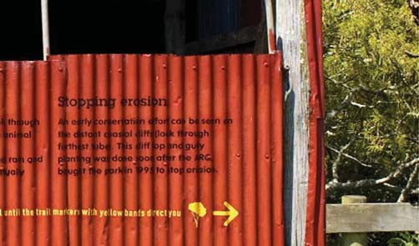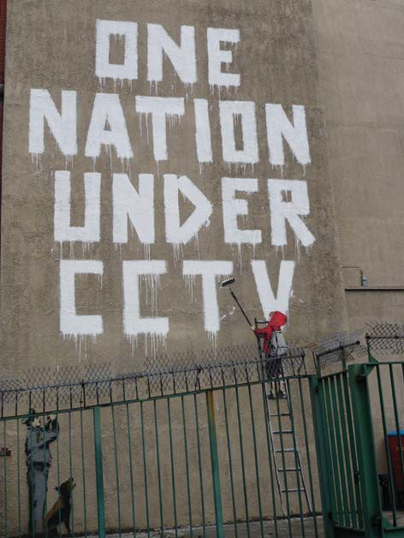Figure 2 Figure 3

Amnesty International poster competition for freedom of speech, M Broughton.

*raf¿ti Street Art Banksy, London, 2008.

Figure 4 Figure 5

ReÀect on the four applications of type in Figures 2 to 5. Choose two examples to discuss in the following questions. Use typographic and communication concepts.

(a) Compare and contrast two examples of the stylistic characteristics of the typefaces.
(3 marks)

(b) Justify how the typefaces are appropriate to the content and application in each design.
(3 marks)

'It is the designer's job to give the public what it wants.'

Using your understanding of ethical and legal responsibilities from a design perspective, explain briefly whether you agree with this statement or not.

4XHVWLRQ 4 (7 PDUNV)

You are part of a design team that has been asked to create a proposal for the re-use of a school assembly hall. The hall has been replaced with a new one and the school administration would like to convert it into something useful for the community.

As part of the design team you are required to consider:
Ɣ possible uses for the hall
Ɣ costs and funding issues
Ɣ project planning.

Components in this project include:
Ɣ reference to the building's history
Ɣ consideration of sustainability
Ɣ community identity
Ɣ space planning.

As a team member, you need to consider the use of the building, what changes need to be made, project costs and project planning.

(a) Describe what process you would use to determine community needs. (3 marks)

(b) What would you have to consider in planning a component of the project? (4 marks)

Explain, using words and diagrams, the differences between a design process and a production process. Show how they relate to each other.

End of Section One

6HFWLRQ 7ZR: ([WHQGHG UHVSRQVH 35% (38 0DUNV)

This section contains six (6) questions.

You must answer Question 6, which is common to all contexts and Question 7, which relates to a given stimulus.

Then answer one (1) context speci¿c question from Questions 8 to 11. Write your answers in the spaces provided.
You must make reference where possible to a different design project when responding to each question.

Spare pages are included at the end of this booklet. They can be used for planning your responses and/or as additional space if required to continue an answer.
Ɣ Planning: If you use the spare pages for planning, indicate this clearly at the top of the page.
Ɣ Continuing an answer: If you need to use the space to continue an answer, indicate in the original answer space where the answer is continued, i.e. give the page number. Fill in the number of the question that you are continuing to answer at the top of the page.

Suggested working time: 120 minutes.

Question 6 (12 marks)

Choose a design that you have carried out this year based on an environmental or political theme. Use diagrams and words to show how you would improve this design in the space below and on pages 10 and 11. Show what factors you would consider and how you would deal with them.

Factors could include design elements and principles; production processes; the creation of meaning; users’ needs; or environmental or political considerations.

Using the following design brief, explain how you would approach this project by answering each of the three questions to demonstrate appropriate and effective design methods and processes.

A developer has decided to build a shopping centre near you. The developer wants to design a building with a contemporary identity and a distinct visual style. It needs to emphasise a sense
of community spirit and suit all ages, especially a younger target audience. The identity needs to include building and landscape design, a logo, a font, templates for printed promotional material and a website.

(a) Justify the role of the designer in developing an appropriate communication strategy for the project. What bene¿ts should a designer be able to offer? (4 marks)

(b) Describe briefly how design concepts, including those such as modernism, post­ modernism and 'form follows function' could influence your ideas for the design brief. Discuss an approach that you might use to apply one of these design concepts to the brief. Use sketches if you wish. (5 marks)

Question 7 (continued)

(c) Explain at what stages of the design process you would use processes of inquiry to create specific meaning. Give examples of the processes of inquiry for two different stages of your design process. (5 marks)

This page has been left blank intentionally

6HFWLRQ 7ZR: ([WHQGHG UHVSRQVH: &RQWH[W VSHFL¿F

Answer one (1) question from Questions 8 to 11 in relation to your chosen context. Write your answers in the spaces provided.

Examine the stimulus provided to answer the questions.

Question 8: Photography context (12 marks)

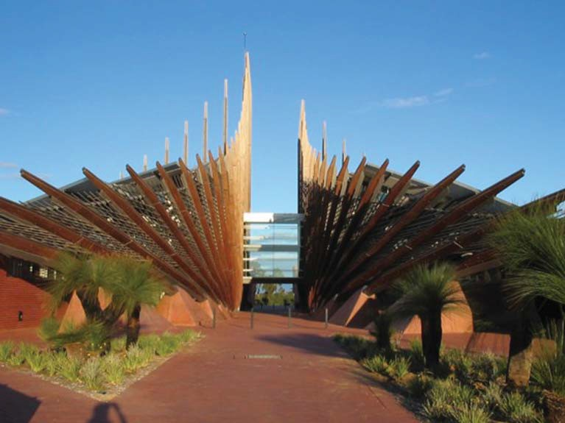
Figure 6

(a) In what ways have the elements and principles of design been used or adapted to inform the design in Figure 6? (4 marks)

(b) Why, in your opinion, did the designer use those particular elements and principles of design? Describe what the designer had to consider when using them. (4 marks)

(c) Explain how meanings are transmitted through these choices of elements and principles of design. (4 marks)

For copyright reasons this image cannot be reproduced in the online version of this document but may be viewed at http://helenweselcouch.wordpress.com

Figure 7

(a) In what ways have the elements and principles of design been used or adapted to inform the design in Figure 7? (4 marks)

(c) Explain how meanings are transmitted through these choices of elements and principles of design. (4 marks)

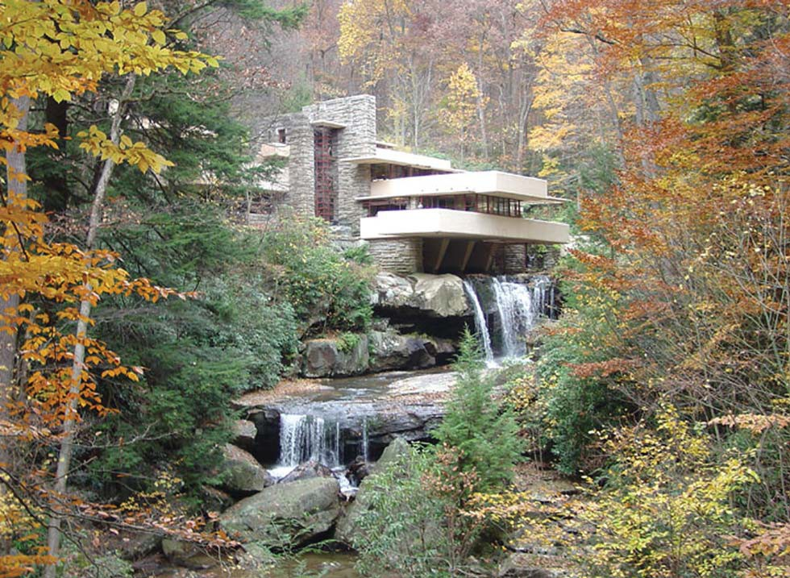

For copyright reasons this image cannot be reproduced in the online version of this document but may be viewed at http://franklinlloydwright.com/famous-works/falling-water-an-architectural-legacy

Figure 8

(a) In what ways have the elements and principles of design been used or adapted to inform the design in Figure 8? (4 marks)

(c) Explain how meanings are transmitted through these choices of elements and principles of design. (4 marks)

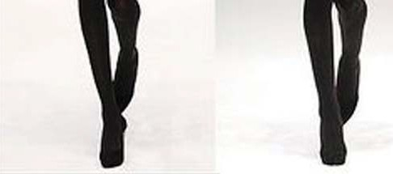

For copyright reasons this image cannot be reproduced in the online version of this document but may be viewed at http://2.bp.blogspot.com/_vyCf6z7uw8E/SdqCmxte7CI/AAAAAAAAnV4/EzLys7H-BBo/s400/mary%2Bkatrantzou%
2Bfall_2009.jpg

Figure 9

(a) In what ways have the elements and principles of design been used or adapted to inform the designs in Figure 9? (4 marks)

(c) Explain how meanings are transmitted through these choices of elements and principles of design. (4 marks)

End of questions

Spare answer pages:

Question number:
(v"')
Planning
Continuing an answer

Spare answer pages:

Question number:
(v"')
Planning
Continuing an answer

Spare answer pages:

Question number:
(v"')
Planning
Continuing an answer

Spare answer pages:

Question number:
(v"')
Planning
Continuing an answer

Additional working space

Section One

Question 1 Adapted from: ArtLook [Lookyanov, A.]. (2004). Domes of the St.
Basil's Cathedral [Image]. Moscow: ArtLook Photography. Retrieved May, 2013, from www.trekearth.com/gallery/asia/russia/center/moscow/ photo99778.htm

Question 2 Adapted from: Timber fin [Image]. (n.d.). In ‘Timber fin’ – The green alternative to the external hotel sign. (2011, January 10). Hotel Designs News. Egham, Surrey: Signbox. Retrieved 2013, from www.hoteldesigns.net/industrynews/news_8410.html

Adapted from: pHd3 Limited. (n.d.). Duder Regional Park gate sign [Image]. Retrieved 2013, from www.phd3.co.nz/auckland-regional- council.php

Adapted from: Broughton, M. (n.d.). Free speech is a right not a privilege [Image]. Melbourne: Matthew Broughton Design. Retrieved
2013, from www.mattbroughtondesign.com/portfolio_freespeech.html

Adapted from: Argent-Katwala, M. (2008, May 29). Banksy art on Newman Street [Image]. Retrieved 2013, from http://gallery.future- i.com/England/pic:banksy-newman/full-size Used under a Creative Commons Attribution Share-Alike licence.

Section Two

Question 8 Alfeewusy. (2007, March 16). Edith Cowan University Joondalup entrance [Image]. Wikipedia. Retrieved January 1, 2013, from http://en.wikipedia.org/wiki/File:Edith_Cowan_University_Joondalup_ entrance.jpg

Question 9 Bishop, J. (2007/ July/August.). The-three-trillion-dollar war: Its cost in ten steps [Image]. Good. Retrieved April 5, 2013, from http://helenweselcouch.wordpress.com

Question 10 Adapted from: Serinde. (2005, May 22). FallingwaterWright [Image].
Wikipedia. Retrieved January 1, 2013, from http://en.wikipedia.org/wiki/Frank_Lloyd_Wright Used under the Creative Commons Attribution-Share Alike 3.0 Unported license.

Question 11 Firstview. (2009, February). Pieces from the Mary Katrantzou fall winter 2009/2010 ready-to-wear collection [Images]. Milan, Italy: Vogue Italia. Retrieved April 5, 2013, from http://2.bp.blogspot.com/_vyCf6z7uw8E/SdqCmxte7CI/AAAAAAAAnV
4/EzLys7H-BBo/s400/mary%2Bkatrantzou%2Bfall_2009.jpg

This document – apart from any third party copyright material contained in it – may be freely copied, or communicated on an intranet, for non-commercial purposes in educational institutions, provided that it is not changed and that the School Curriculum and Standards Authority is acknowledged as the copyright owner, and that the Authority’s moral rights are not infringed.

Copying or communication for any other purpose can be done only within the terms of the Copyright Act 1968 or with prior written permission of the School Curriculum and Standards Authority. Copying or communication of any third party copyright material can be done only within the terms of the Copyright Act 1968 or with permission of the copyright owners.

Any content in this document that has been derived from the Australian Curriculum may be used under the terms of the Creative Commons Attribution-NonCommercial 3.0 Australia licence.

Published by the School Curriculum and Standards Authority of Western Australia
27 Walters Drive
OSBORNE PARK WA 6017

