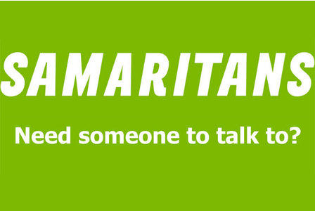
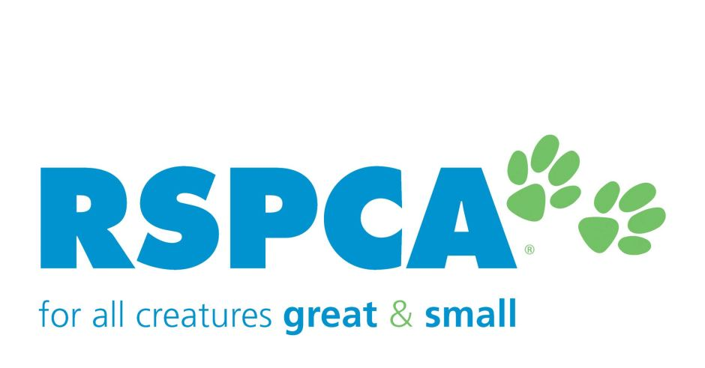
Design – ATAR Year 12

Unit 4 Assessment type: Production

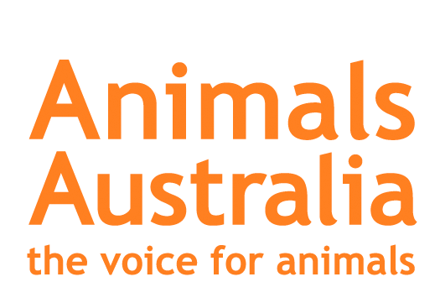
Conditions

Due Semester 2 Term 3 Week 3

Task weighting: 12.5% of the school mark for this pair of units
__________________________________________________________________________________

Influential design (42 marks)
Congratulations! You are working in the Creative Industries. You have scored an intern position working for the Western Australian branch of WPP – WA’s premier Design Solutions agency based in Fremantle.
For you to gain a paid graduate position you need to show your skills in creatively interpreting a brief. To enable your success your agency has given you free rein of across their pro-bono clients. In offering a Design solution package you must employ strong persuasive techniques in promoting their clients organization. You must select one issue-based campaign that the organization runs and create a campaign for that issue.
Your design solution must take the form of ONE final persuasive poster suitable for a print and digital display. You are required to create two prototypes with distinct Design solutions. Your solutions can incorporate a Portrait or Landscape layout. You must apply appropriate typographic elements. You should experiment with Photo Montage and associated techniques.
Your final design solution will feature on your clients website .You must ensure you appeal to your clients specific target audience by undertaking relevant research .You will need to analyse the audience in terms of empathy, profiling and stereotyping.
Objective: Design a persuasive poster that influences opinion and attitudes
Ensure you appeal to your target audiences in your creative approach. You are required Persuasive Techniques that must be utilised include; Humour, Shock, Metaphor and Emotion.
Don’t restrict yourself to literal interpretation; feel free to branch your design ideas out into a creative array of images featuring people, places, interpretations of feelings or emotions and/or original artworks that may be conceptually related to the brief.

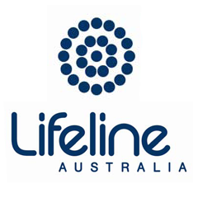
Your final design solutions and the design process you applied will be compiled in a design portfolio. This must be at least 10 pages but can be up to 15. In the portfolio you must clearly show your research, analysis, experimentation of ideas and refinement of final design solutions. You must also be able to self -reflect on your process and product using Design terminology and application of Semiotics.

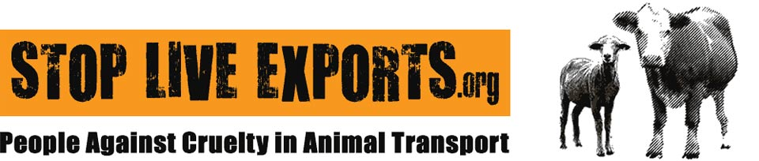

Task description
- You will conduct research, collecting information and visual material related to your poster. To do this, you will need to:
- interpret the design brief
- define and understand your target audience so you can effectively apply semiotics, codes and conventions relevant to design
- explore design principles relevant to the task: form follows function
- collect and analyse existing visual images and information on poster design.

- You will investigate and plan for suitable design solutions. To do this, you will need to:
- apply a design process and consider a commercial design process
- investigate a successful communication model relevant to the design brief
- understand the cultural values, ideologies and belief systems that are important to society and individuals
- recognise the influences of theories and media forms on all stakeholders
- experiment with the application of type and colour relevant to your chosen theme, content and target audience.

- You will apply ideation techniques to generate suitable designs by:
- exploring various design methods to generate possible design solutions: visual research, idea generation techniques, synectics, mind maps, brainstorming
- applying inquiry processes to formulate specific meaning in your design work, including investigation of currently available materials and technologies
- analysing and evaluating appropriate strategies for communication to your intended audience: shock tactics, humour, metaphor and emotion
- experimenting with the characteristics and application of design elements and principles, possibly including Gestalt design principles, colour theory, layout principles and visual hierarchy.

- You will need to develop and refine your design solutions by:
- creating visuals/layouts to document your visual development to reflect progressive resolution of design problems and thinking
- planning for production by considering costs and constraints, sustainability and life-cycle costing
- considering possible future trends when selecting suitable production processes and specific production materials and/or technologies appropriate to the design brief
- applying skills relevant to the production
- conducting critical reflective analysis to devise and evaluate solutions to design problems and to refine production processes and methods
- understanding occupational safety and health (OSH) concepts and their impact in design.

NOTE: You will be marked against the eight criteria listed in the attached marking key.

Description | Marks
Criterion 1: Application of planning
(Evidence of use of organisation and planning in the design and production processes, such as: design brief, intended audience, time management and/or production plan, mind maps, materials lists, model release forms, budget, costing quotes, surveys or others appropriate to context.)
Demonstrates comprehensive, detailed and relevant planning in the design and  production processes | 5
Demonstrates detailed and relevant planning in the design and production processes | 4
Demonstrates relevant planning with some detail in the design and production processes | 3
Demonstrates some relevant planning in the design and/or production processes | 2
Demonstrates minimal planning in the design and production processes | 1
No evidence of planning | 0
Total | 5
Criterion 2: Application of skills, techniques, procedures
(Evidence of competence in skills, techniques, procedures for production, such as: sketching, rendering, handling of materials, prototypes, manipulation of IT programs and quality high resolution images.)
Employs extensively and successfully a range of skills, techniques and/or procedures for production relevant to the design brief | 5
Employs effectively a range of skills, techniques and/or procedures for production suited to the design brief | 4
Employs with some effect a range of skills, techniques and/or procedures for production suited to the design brief | 3
Employs some skills, techniques and/or procedures for production suited to the design brief | 2
Employs a limited range of skills, techniques and/or procedures for production  suited to the design brief | 1
No evidence of the use of skills, techniques and/or procedures for production | 0
Total | 5
Criterion 3: Experimentation
(Evidence of experimentation, choice of design solutions, such as: variety of sketched ideas,
alternative options investigated, variations of ideas, colour, type, composition, experimenting with materials, media, methods, changes are significant, relevant and justified.)
Demonstrates meticulous and sophisticated experimentation and considered choice of possible design solutions | 6
Demonstrates extensive and detailed experimentation and choice of possible design solutions | 5
Demonstrates effective experimentation and choice of possible design solutions | 4
Demonstrates experimentation with some effectiveness and choice of possible design solutions | 3
Demonstrates some experimentation and choice of possible design solutions | 2
Demonstrates limited experimentation and choice of possible solutions | 1
No experimentation of design solutions | 0
Total | 6

Description
Criterion 4: Annotations and analysis
(Evidence of use of analysis, clear thinking and sound reasoning using design terminology, such as: notes or ideas on referenced images, annotation of processes relevant to design brief and intended audience, critical analysis of final solution, use of design terminology throughout.)
Provides extensive annotations and detailed critical analysis of relevant information using design terminology | 5
Provides detailed annotations and critical analysis of relevant information using design terminology | 4
Provides clear annotations and some analysis of relevant information using design terminology | 3
Provides simple annotations and/or some analysis, mainly relying on supplied information using design terminology | 2
Provides minimal annotations and analysis | 1
No evidence of annotations and analysis | 0
Total | 5
Criterion 5: Originality
(Evidence of innovation and originality, such as: original designs and/or own images, exploration of unique ideas and concepts throughout the portfolio, acknowledgement of borrowed images.)
Uses sophisticated concepts/ideas to develop original and highly innovative design solution(s) | 5
Uses effective concepts/ideas to develop original and innovative design solution(s) | 4
Uses some effective concepts/ideas to develop design solution(s) that display some originality and innovation | 3
Uses concepts/ideas to develop design solution(s) with little originality andinnovation | 2
Uses basic concepts/ideas to develop simple design solution(s) | 1
No evidence of originality or innovation | 0
Total | 5
Criterion 6: Design elements and principles
(Evidence of effective selection and application of design elements and principles, such as: experimentation and application of elements and principles throughout, application of these in final solution, justification linked to design brief and intended audience.)
Demonstrates successful discernment in selecting and applying relevant design elements and principles with detailed pertinent justification | 5
Demonstrates effective experimentation and application of relevant design elements and principles with relevant justification | 4
Demonstrates some effective experimentation and application of design elements and principles with some relevant justification | 3
Demonstrates experimentation and application of design elements and principles inconsistently and with some justification | 2
Demonstrates minimal experimentation and application of design elements and principles with minor justification | 1
Displays no evidence of the application of design elements and principles | 0
Total | 5

Description | Marks
Criterion 7: Design process
(Evidence of competence in the application of a design process; idea generation/ideation, design development, refinement, production and evaluation, such as: investigation of design brief, visual research, idea generation techniques, visual development with progression of ideas, refinement, final resolved design solution.)
Demonstrates a meticulous and comprehensive application of an appropriate design process | 5
Demonstrates a coherent application of an appropriate design process | 4
Demonstrates a competent application of an appropriate design process | 3
Demonstrates a basic application of a design process | 2
Demonstrates minimal application of a design process | 1
No application of a design process | 0
Total | 5
Criterion 8: Communication and visual literacies
(Ability to respond to a design brief and construct a final design solution(s) that conveys a message to the intended audience, such as: final resolved design solution, relevant response to design brief and intended audience, professional quality and appearance, stands alone as a communicative work.)
Presents a sophisticated and highly effective communicative final design solution(s) that conveys an articulate and engaging message to the intended audience in response to the design brief | 6
Presents a highly effective communicative final design solution(s) that conveys an engaging message to the intended audience in response to the design brief | 5
Presents an effective communicative final design solution(s) that conveys a clear message to the intended audience in response to the design brief | 4
Presents an appropriate final design solution(s) that conveys a clear message to the intended audience in response to the design brief | 3
Presents a final design solution(s) that conveys, in a limited way, a message to the intended audience in response to the design brief | 2
Presents an incomplete final design solution(s) that conveys, in a minimal way, a message to the intended audience in response to the design brief | 1
No final design solution presented | 0
Total | 6

