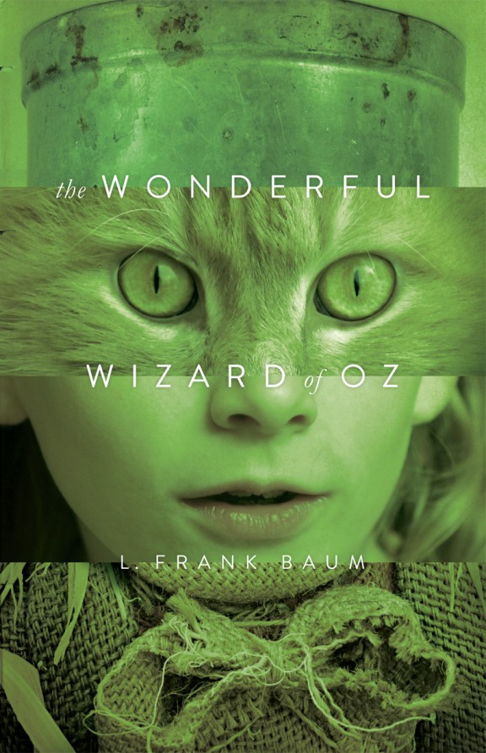
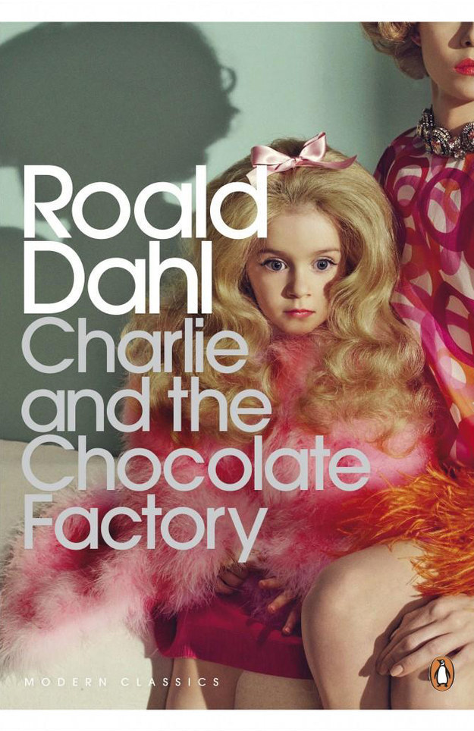
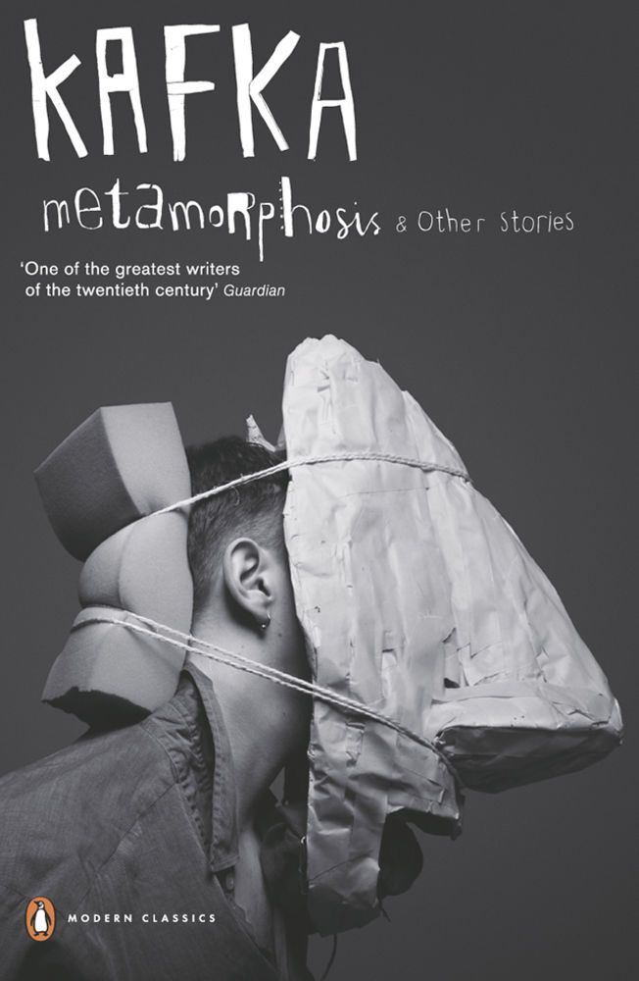
Unit 3
Commercial Design Brief

Time allocation: 12 weeks
15 Page portfolio due Week 2 Term 1

Design brief: Promotional Images for a Young Adult Book

The Young Adult book market is a highly lucrative industry stretching across print and digital arenas influencing genre, representation and direction of other entertainment industries such as Film and TV productions.

Appealing to this valuable client base is essential in supporting the publishing industry. Moving into the digital realm has enabled books to be accessed through new technology, however hard copy books are still popular in 2019. In working with this esteemed and well-regarded client you will be expected to produce work that can be printed economically and published online. You should also note that criticism has been levelled at the YA book market for perpetrating gender stereotypes in their cover art and it is this aspect that your client wishes to avoid.
Be aware that a 2012 study on the teen and YA book market found the majority of its readers (55%) are actually adults.

Don’t restrict yourself to literal interpretation; feel free to branch your design ideas out into a creative array of images featuring people, places, interpretations of feelings or emotions and/or original artworks that may be conceptually related to the book constraints.
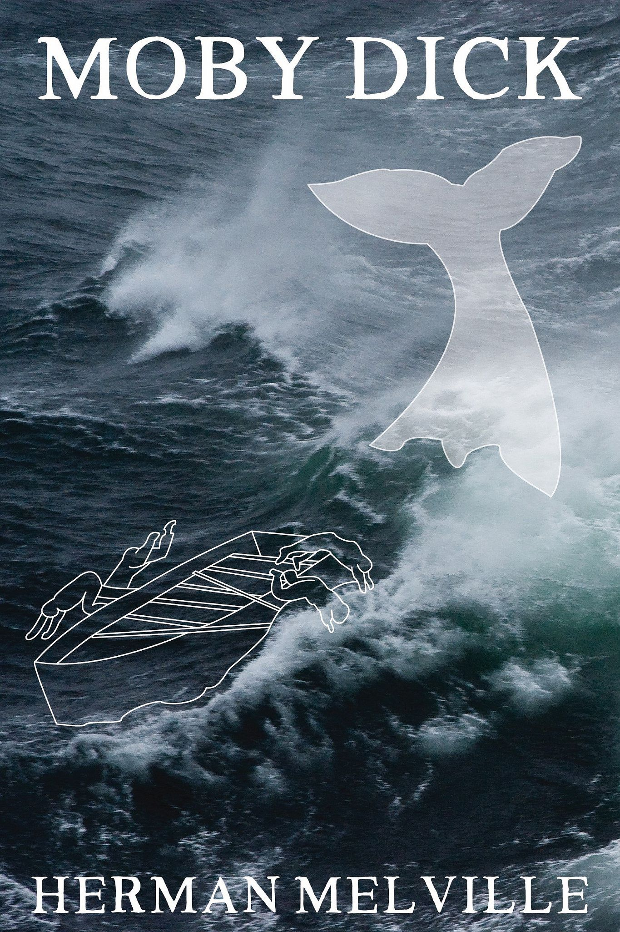
Objective: You are required to explore four prototypes leading to a single final design solution, for the promotion of a ‘repackaged’ or ‘reimagined ‘classic novel as a YA book title. These must take the form of a photography based promotional image for first release. Ensure you appeal to the indicated target audiences in your creative approach to the task. You will create either ‘gender specific’ and/or a ‘non-gender’ specific image for the title. Consider the book title, author name, and art direction. These can be developed and altered to suit the book theme and genre, and intended audience.

Possible approaches to genre include (but are not limited to):

- Science Fiction:
- Romance:
- Fantasy:
- Thriller/Horror

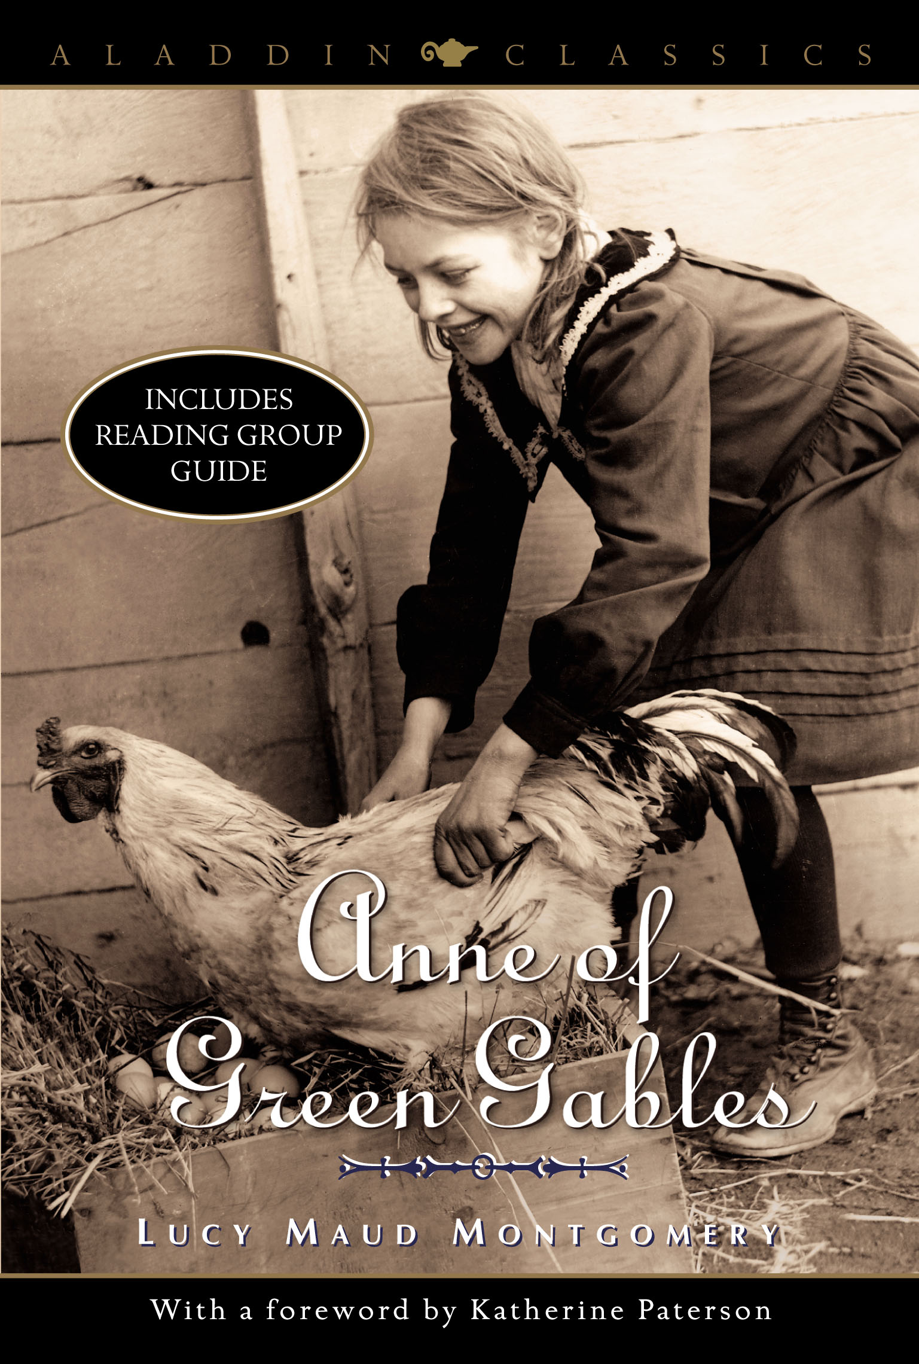
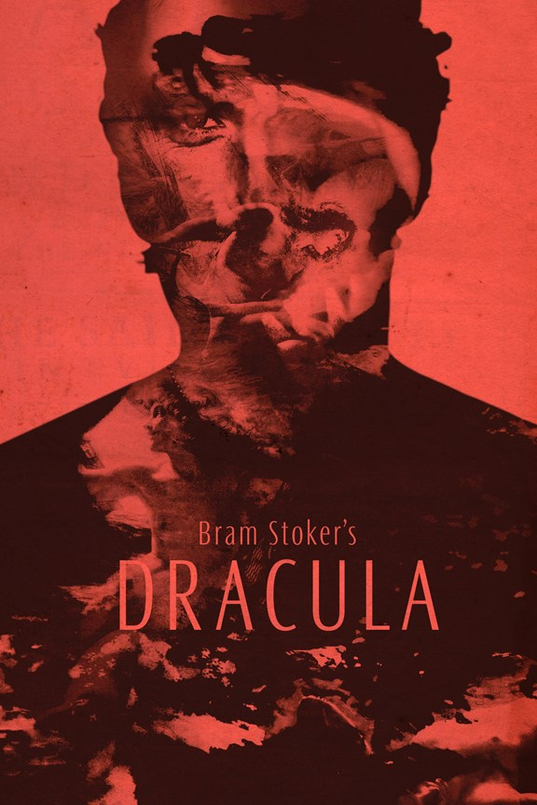
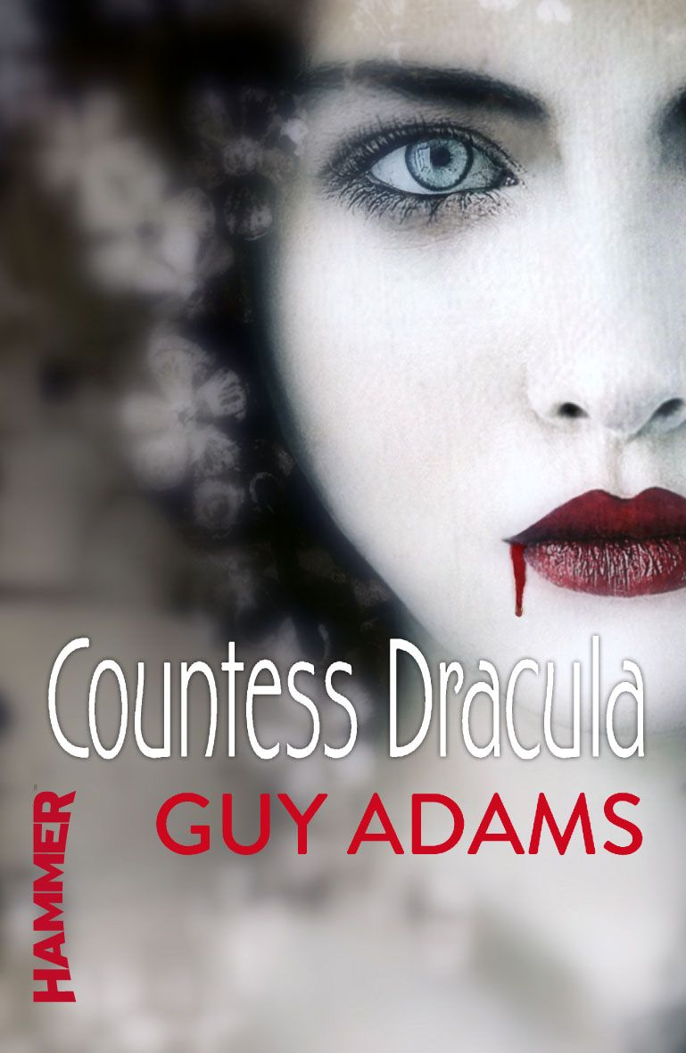
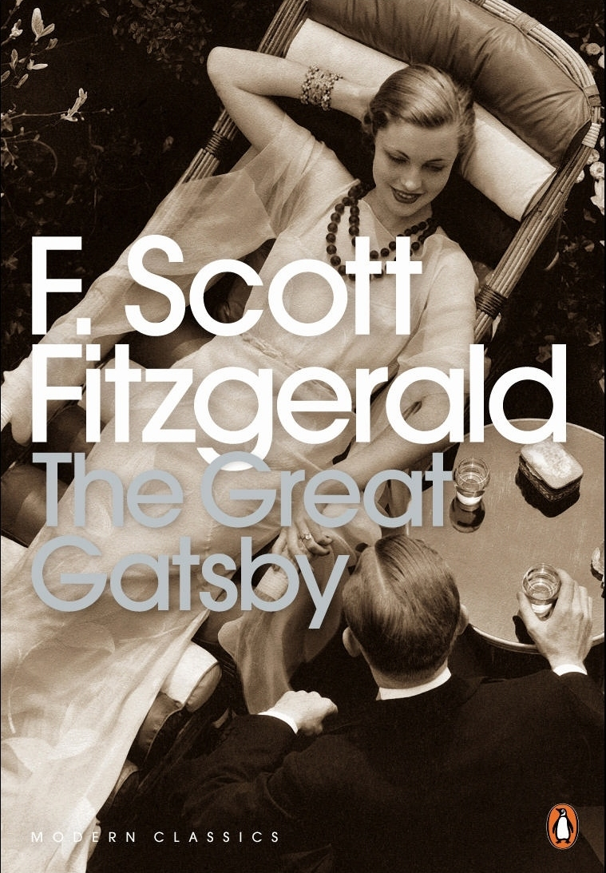
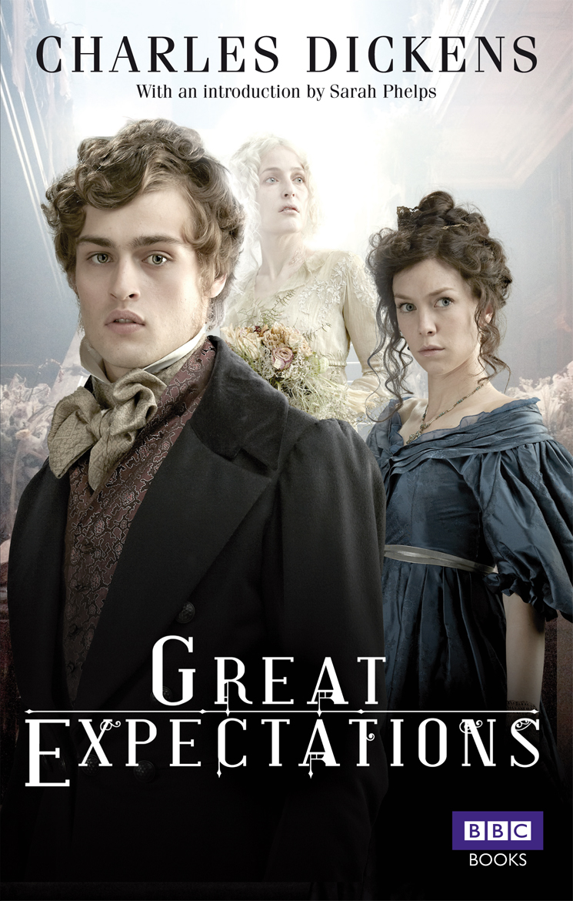
Suggested Portfolio Format

Page 1: Production Planning/Research & Ideation

- Student Name.
- Course Name.
- Index.
- Design Brief.
- Survey of Target Audience.
- First Stage of Ideation- mind map.

Page 2: Production Planning/Research.

- Timeline of project.
- Challenges identified and Strategies for Management.
- Technologies & Materials you will use in Process and Production of your Design Solution.

Collect Book Promotion products of a similar nature to the one you have chosen;

- Analyse the design. What makes it a successful campaign?
- Examine its appeal using Visual Codes/DEP to a target audience.
- What techniques does it use? Detail this so you ensure yours is effective and appealing.

Page 3: Genre Ideation
- Draft ideas on Genre
- Create rough sketches – digital
- Apply of visual codes/symbolism from genre

- Apply annotation and DEP to your chosen Synetics.

Page 4: Ideate/Synectics
- Focus on experimentation of four ideas for different Target Audiences for one classic book in your genre using Synectics
- Experimenting with sketches / digital illustrations

Page 5-8: Planning & Design Development; 4 ideas
- Outline all of the necessary components of your Photo Shoot planning- be expansive. Detail as many different pathways to a Design Solution that you can;
- Shooting Plans,
- Design Development and annotations
- Contact page with camera settings
- Annotations on colour, type, lighting plans, graphics.
- Create final prototypes

Page 9: Test & Evaluate

- Survey of Prototypes/concepts to target Audience
- Feedback of any possible refinements.
- Evaluation of responses.
- Use feedback to ensure the design has the intended effect.

Page 10: Design Development
- Reshoots and actions taken from Feedback.
Page 11-13: Design Development- Experimentations on Final Design.
- Explore DEP, Synectics, Visual Codes.

Page 14: Design Development- Refinements

- Show your process of refinements from the RAW file to the finished design.
- Evaluate image development- how and why the image has been edited as design has progressed.
- Survey a focus group to gain feedback of success of the success of your design.

Page 15: Final Design. ANNOTATION: What is the production & commercial How have you met the brief and Target audience

List of References;
All images you have not taken must be referenced.
This is on a separate SCASA document.

Suggested Portfolio Layout
PAGE 1  Define:  Design Brief: Own Words.  Empathize:  Survey: Who is your target audience? VALS, Demographics,  Define:  Ideate/Research  Initial Ideas- Mind Map genre, publishing companies, genre aesthetics, visual codes,symbolism | PAGE 2  Define:  Production Planning  Timeline.  Challenges & Strategies. Technologies Process & Production.  Campaign Analysis  In detail – use analysis guideline sheet. | PAGE 3  Digital Sketches  Draft ideas rough sketches, application of visual codes, DEP | PAGE 4  Synectics  Focus on four ideas for different Target Audiences  classic books in your genre  Gain feedback on initial Test prototypes | PAGE 5-8  Prototype x4 :  Ideation into Action -Design Developments- Image Selection  Photo Mock ups with shoot details, OHS, annotations,  Camera / Studio info.  What photo will be used / not used? | PAGE 9  Test & Evaluate: Prototypes  Survey – Pie Charts  Feedback-Evaluate-Develop
Page 10  Design Development;  Reshoots, refine, Synectics – explore new Typeface, Layout, New Photos or a whole new idea. | PAGE 11-13  Final Prototype Experimentation:  Design Development  Experiment DEP, Visual Codes, Type & SCAMPER | PAGE 14  Design Refinements  Focus group feedback  Production Process / Commercial Consideration  Sustainability  Limited Edition  Art work options | PAGE 15  Evaluation of Final Design  DEP  Genre Conventions  Target Audience  Brief  Communication Model  Persuasive Techniques  Colour  Lighting  Symbolism  Typeface  Genre Conventions  Skills Used

