Design ATAR course Practical (portfolio) examination 2020
References/acknowledgements
WA student number:
Instructions to candidate
The candidate is required to acknowledge sources of information (references, appropriations, attributions) used in the practical portfolio submitted for assessment. Your references and acknowledgements should include:
- all references (i.e. another person’s ideas, works or images) used in the investigation and development of design concepts. All images obtained from the internet should contain the URL as shown in the example below
- the name of the software package of the CAD and/or graphics editing software used throughout the practical (portfolio) examination submission
- acknowledgements must be made on this official form and are to be word processed, using 11 point Arial font.
Software program used | Design use of software
E.g. Adobe Photoshop | Photo editing and manipulation
E.g. Adobe InDesign | Portfolio layout
E.g. Autodesk Revit | 3D model construction and rendering

Thumbnail of image used | Page it appears  in the folio | Current authentic and specific URL
E.g. | 2 | https://blog.urbanoutfitters.com/blog/king_brown_magazine_issue_8_launch_exhibition
E.g. 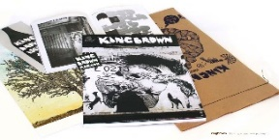 | 6 | http://www.trespassmag.com/interview-ian-mutch/

